**Performance Test Report**

**For**

**Execution of**

**Masterdata documenttype – 250 users**

Date: 04 June 2020

Author: Gaurav Sharan

**Summary**

This report presents the observations and findings of the load test conducted for a load of 250 users on masterdata documenttype API.

The objective of this load test was to observe and record behavior of the application when user load is increased from 50 to 250.

Below are the scenario details:

|  |  |
| --- | --- |
| **Script/Report Name** | Masterdata documenttype API |
| **Run Date** | 04-June-2020 |
| **Period** | 12:46:34 UTC to 14:05:13 UTC |
| **Number of concurrent users** | 50 to 250 |
| **Ramp up** | 01 users per second |
| **Run Duration** | --- |
| **Ramp down** | NA |

The transaction response times observed were as below:

|  |  |  |  |  |  |  |  |
| --- | --- | --- | --- | --- | --- | --- | --- |
| **Label** | **# Samples** | **Average(ms)** | **90% Line(ms)** | **Min(ms)** | **Max(ms)** | **Error %** | **Throughput** |
| TR_masterdata_  documenttype | 488543 | 857 | 1236 | 8 | 60045 | 0.01% | 102.7 |

**Performance Test Execution Details**

We have executed JMeter script for masterdata documenttype service, which has transactions mentioned in the above table.

Average response time of the APIs is 857 ms with error rate ~0 %.

**Response Time and TPS Graph:**

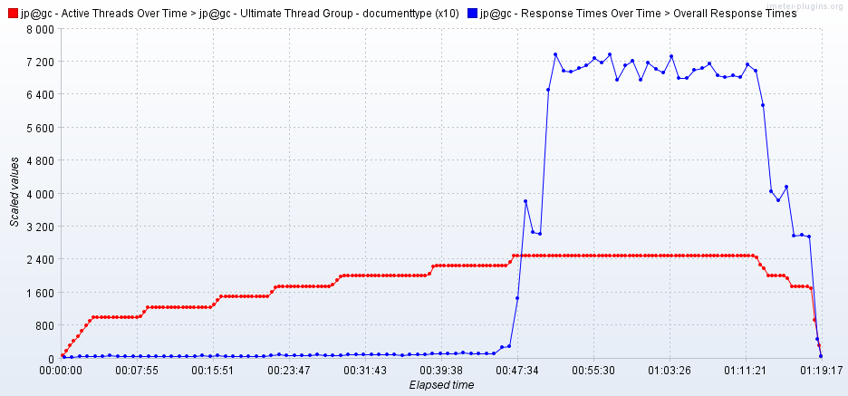

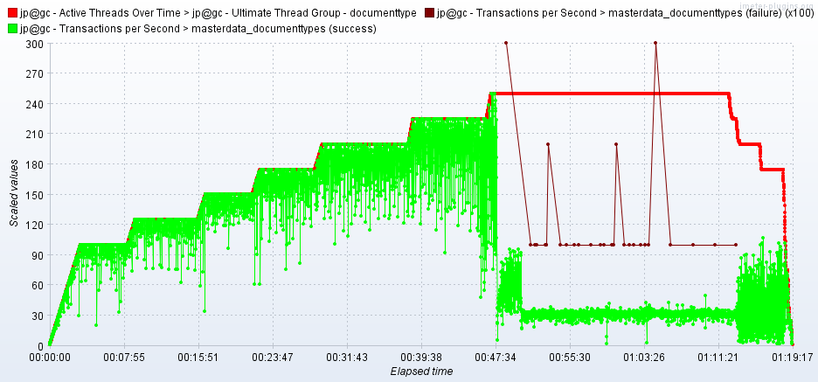

As seen in the graph, response time of the APIs is approx 150 milli second when 225 users are active, then response time increases to 7 seconds when 250 users are active.

Failures are observed when 250 users are active.

Throughput (TPS) of the APIs approxes 200 when 225 users are active and reduces to 31 when 250 users arrive